Wingspan
Lite
The Newsletter of the Christian Schools’ Trust
‘Love your neighbour as yourself?’: Practical engagement with local community needs.
By Steve Beegoo, Principal of The King’s School, Witney
Every school’s value statement includes something related to building character traits and goes beyond academic achievements alone. I often find myself saying to prospective parents, ’You wouldn’t want your child to have an A star in Maths and go swindle people with their skill, would you?!’. At The King’s School Witney, we have always given teams of older students the opportunity to travel to impoverished parts of Africa, China or India, to serve and bless people and experience the joy of self-sacrifice. But the daily challenges of local people from the more imminent community of which they are part are so close, and yet can feel so far away. We wondered what we could genuinely do to build into our students a love for their fellow man locally. A love which could grow and demonstrate itself through real, practical, useful, community changing ways.
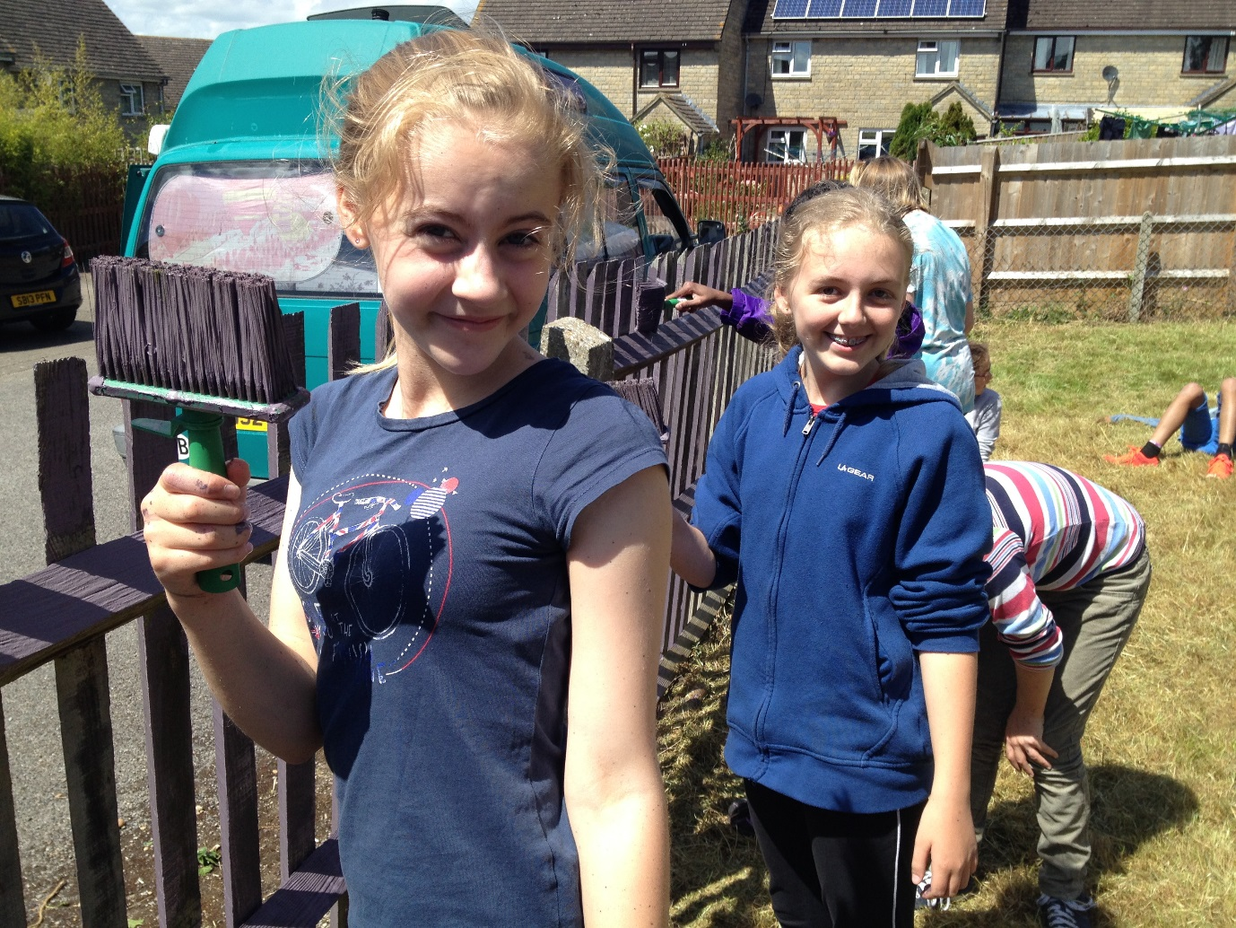

We believe we have found an answer to this question! Six years ago, we started to work together with a national charity called ‘The Besom’. We started to plan activities over three days towards the end of each summer term. What has evolved over these years has been what I can only describe as the love-child of ‘DIY SOS’ and ‘Groundforce’! In working with a charity, that has close links to really needy situations, students from Y7 to Y10 give hours of service in well supervised and resourced teams, to develop the homes and gardens of vulnerable families or other community facilities. Staff, students and even some parents, combine together to work over one or two days at carefully chosen local sites as part of their end of year activities.
Over these six years, we have completed over 50 projects and given over 4,500 hours of practical service in ways which have made a huge impact on some of the most needy in our community.
Some examples will help explain: G had not been able to look after her garden since her husband’s death. She had experienced a lot of abuse and name calling from local teenagers when in her front garden, and so had become fearful of young people and anxious to even be outside. Because of her vulnerability and her difficulties in managing the home, her tenancy had become at risk, as was her health. From relationship through ‘The Besom’, she tentatively agreed that a group of pupils, supported by a teacher could spend half a day simply tidying up her front garden. She was overwhelmed by how kind and polite the children were and the quality of the work they had done. She enjoyed it so much that she immediately invited two other groups back to clear her back garden for her! This was completely overgrown and severely and dangerously encroaching on the back of the house. As a result of the gardens being eventually reclaimed, she was able to apply for a relocation to a more suitable bungalow and groups from the school went back in following years to work on her new garden to make it as low maintenance as possible for her. The students gained so much from building on the relationships of previous project groups, enjoying interacting with the lady who has now grown to delight in their company.
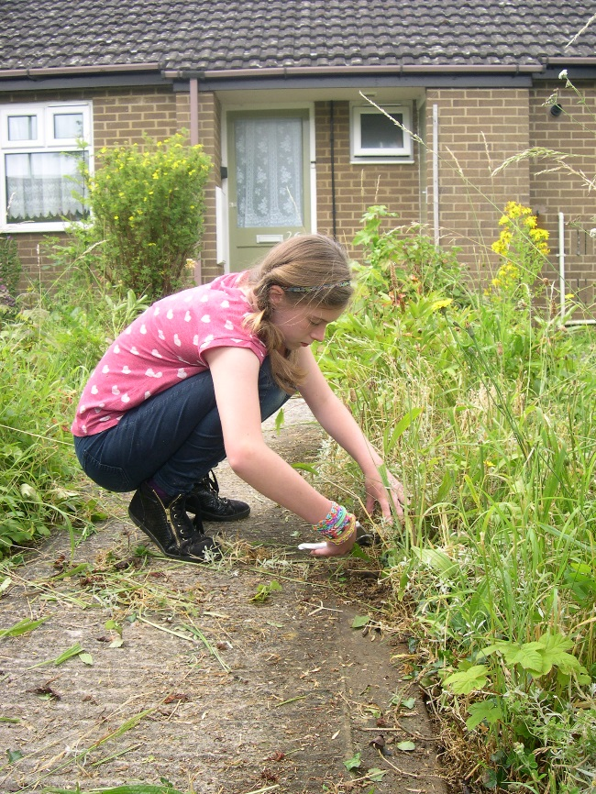
You cannot imagine how valued she has felt in receiving the garden makeovers, now her husband is no longer with her. Her fear of teenagers had subsided. Moreover, the students were able to easily make the connection between what they were doing as an act of practical service and the difference it would make to a real, local person’s life.
You can imagine that the stories are numerous. Another which stands out relates to a mental health housing project. ‘The Besom’ regularly works with Oxfordshire Mind, in preparing homes for occupancy for someone needing supported living until they are well enough to live independently. The charity provided furniture and household items and a team of students collected and unpacked everything to literally ‘create a home’ ready for the person to occupy from hospital. It was amazing to see the thoughtfulness that had gone into selecting and organising the items; the quality of the colour coordination, with practical and useful choices as well as beautiful ‘finishing touches’ such as a patterned vase and fruit bowl. They greatly enjoyed ‘playing house’ to arrange everything, hang curtains and make the bed. One student was so moved by the project, that she subsequently went to Oxfordshire Mind for work experience and is now at university studying to be a social worker.
And what do we get from this? If you have seen any of these ‘make a difference’ programmes based on volunteering, you will know the hard work and problem solving involved in clearing undergrowth, developing play spaces or decorating rooms. You will also know the team spirit that develops and something of the joy of the experience of blessing someone who could never have accomplished such tasks by themselves. There is nothing like knowing through real experience that you have made a difference to the elderly woman on her own, the mentally ill person who feels forgotten or the struggling single mother of a physically disabled child. The pupils understand at a local level, the impact of the school virtue of sacrificial love that we are seeking to develop. And it is happening in these streets, these houses, where we live. We have a serious desire to build inner character that causes our students to want to be part of the solution for society, whichever sphere of life they ultimately live and work in. We believe in breaking the cycles of selfishness, and the mantras of materialism which our teenagers can absorb, and instead we believe we can build in a desire to work for the common good, so pupils learn to ‘love their neighbour as themselves’.

Is it difficult to organise? Absolutely. Is it hard to pull this together with so many potential projects? Very much so. Do you have to regularly explain why are we doing this to the students and staff? Oh yes! Is it worth it? Utterly!!! If you are interested in grounding the citizenship values that you teach in your local community, then I believe such an approach can build a deeper foundation into your character education, which little else can match.
Steve Beegoo is the Principal of The King’s School Witney: ISA London North
The Besom have centres up and down the country and can be contacted through www.besom.com
